Frequent pattern Mining using FP growth

Upper bound min_support=1.0

Lower bound min_support=0.1

Matric type=Confidence

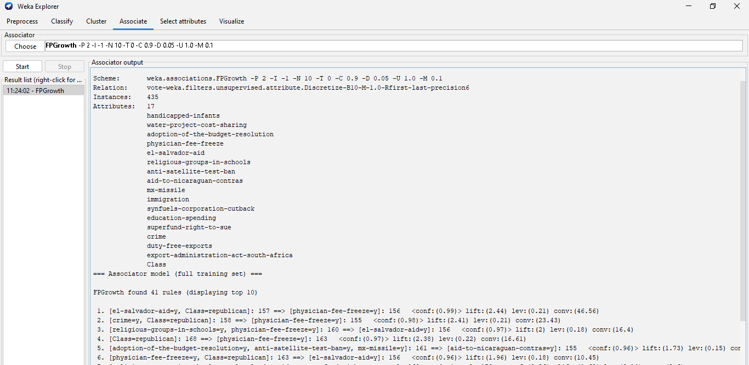

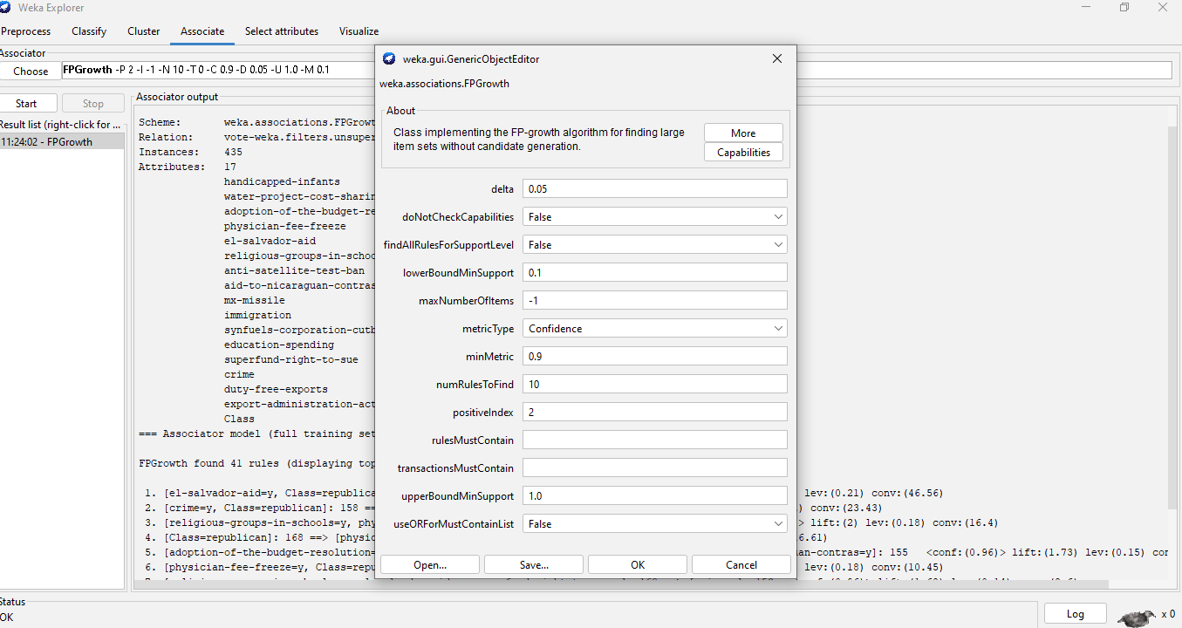

Upper bount min_support=2.0

Lower bbund min_support=1.0

Matric_type=confidence

